|  |
| --- |
| **VISVESVARAYA TECHNOLOGICAL UNIVERSITY**  **“JnanaSangama”, Belgaum -590014, Karnataka.**    **LAB RECORD**  **Bio Inspired Systems (23CS5BSBIS)**  ***Submitted by***  **B Prabhanjan(1BM23CS060)**  ***in partial fulfillment for the award of the degree of***  **BACHELOR OF ENGINEERING**  ***in***  **COMPUTER SCIENCE AND ENGINEERING**    **B.M.S. COLLEGE OF ENGINEERING**  **(Autonomous Institution under VTU)**  **BENGALURU-560019**  **Aug-2025 to Dec-2025** |

**B.M.S. College of Engineering,**

**Bull Temple Road, Bangalore 560019**

(Affiliated To Visvesvaraya Technological University, Belgaum)

**Department of Computer Science and Engineering**



**CERTIFICATE**

This is to certify that the Lab work entitled “ Bio Inspired Systems (23CS5BSBIS)” carried out by **B Prabhanjan (1BM23CS060),** who is bonafide student of **B.M.S. College of Engineering.** It is in partial fulfillment for the award of **Bachelor of Engineering in Computer Science and Engineering** of the Visvesvaraya Technological University, Belgaum. The Lab report has been approved as it satisfies the academic requirements of the above mentioned subject and the work prescribed for the said degree.

|  |  |
| --- | --- |
| Dr Raghavendra C K  Assistant Professor  Department of CSE, BMSCE | Dr. Kavitha Sooda  Professor & HOD  Department of CSE, BMSCE |

**Index**

|  |  |  |  |
| --- | --- | --- | --- |
| **Sl.**  **No.** | **Date** | **Experiment Title** | **Page No.** |
| 1 | 18/08/2025 | Genetic Algorithm for Optimization Problems | 4-7 |
| 2 | 25/08/2025 | Optimization via Gene Expression Algorithms | 8-11 |
| 3 | 01/09/2025 | Particle Swarm Optimization for Function Optimization | 12-14 |
| 4 | 08/09/2025 | Ant Colony Optimization for the Traveling Salesman Problem | 15-18 |
| 5 | 15/09/2025 | Cuckoo Search (CS) | 19-21 |
| 6 | 29/09/2025 | Grey Wolf Optimizer (GWO) | 22-26 |
| 7 | 13/10/2025 | Parallel Cellular Algorithms and Programs | 27-30 |

Github Link:

https://github.com/Prabhanjann/BIS

**Program 1**

We have multiple jobs and limited resources and we need to assign them to minimize completion time, cost or maximize efficiency.

Algorithm:

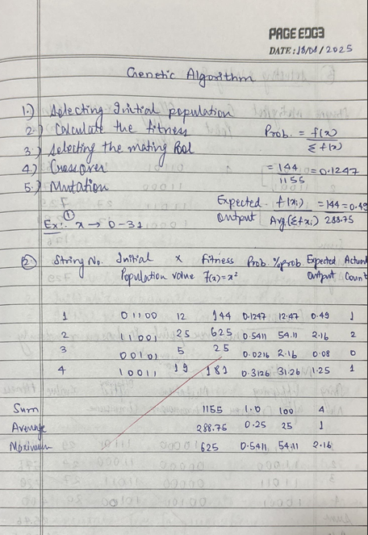

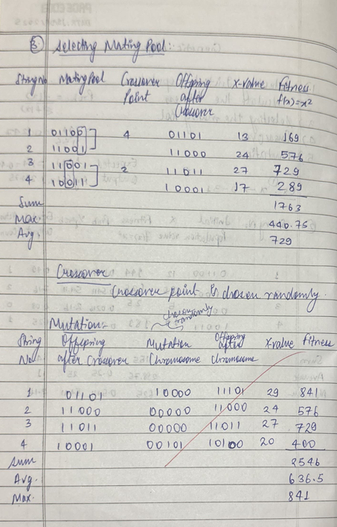

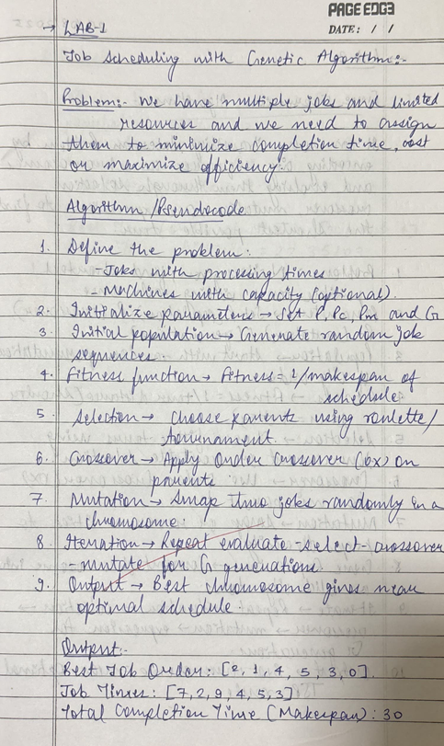

Code:

import random

jobs = [3, 2, 7, 5, 9, 4] # processing times of jobs

num_jobs = len(jobs)

population_size = 20

generations = 100

crossover_rate = 0.8

mutation_rate = 0.2

# ------------------------------

# Fitness Function (Makespan)

# ------------------------------

def fitness(chromosome):

time = 0

for job in chromosome:

time += jobs[job]

return 1 / time # smaller time → higher fitness

def initial_population():

population = []

for _ in range(population_size):

chromosome = list(range(num_jobs))

random.shuffle(chromosome)

population.append(chromosome)

return population

def selection(population):

contenders = random.sample(population, 3)

contenders.sort(key=lambda chromo: fitness(chromo), reverse=True)

return contenders[0]

def crossover(p1, p2):

if random.random() < crossover_rate:

a, b = sorted(random.sample(range(num_jobs), 2))

child = [-1] * num_jobs

child[a:b] = p1[a:b]

fill = [x for x in p2 if x not in child]

j = 0

for i in range(num_jobs):

if child[i] == -1:

child[i] = fill[j]

j += 1

return child

return p1[:] # no crossover → copy parent

def mutate(chromosome):

if random.random() < mutation_rate:

a, b = random.sample(range(num_jobs), 2)

chromosome[a], chromosome[b] = chromosome[b], chromosome[a]

return chromosome

population = initial_population()

best_solution = None

best_fit = -1

for gen in range(generations):

new_pop = []

for _ in range(population_size):

parent1 = selection(population)

parent2 = selection(population)

child = crossover(parent1, parent2)

child = mutate(child)

new_pop.append(child)

population = new_pop

# Track best

for chromo in population:

fit = fitness(chromo)

if fit > best_fit:

best_fit = fit

best_solution = chromo

print("Best Job Order:", best_solution)

print("Job Times:", [jobs[j] for j in best_solution])

print("Total Completion Time (Makespan):", sum(jobs[j] for j in best_solution))

Output:



**Program 2**

The Travelling Salesman Problem (TSP) asks for the shortest possible route that visits a given set of cities exactly once and returns to the starting city. The provided text describes using a Genetic Algorithm to solve this by evolving city sequences (chromosomes) through selection, crossover, and mutation to minimize the total tour distance.

Algorithm:

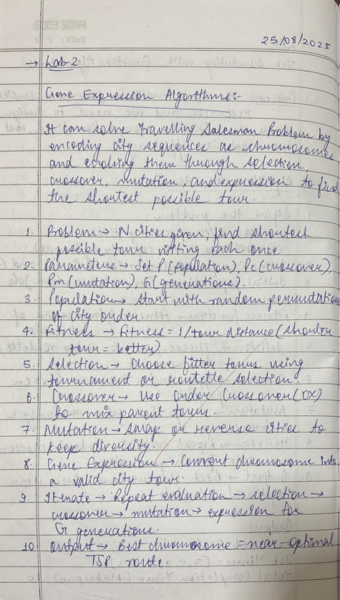

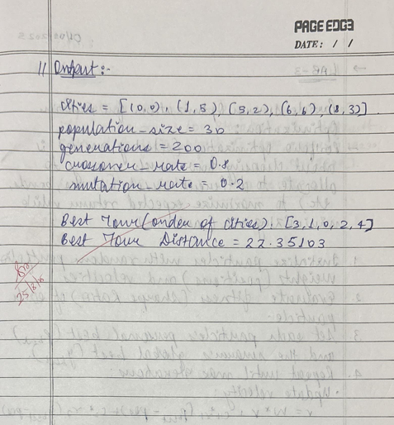

Code:

import random

import math

# ----------------------------

# Problem: TSP cities

# ----------------------------

cities = [(0,0), (1,5), (5,2), (6,6), (8,3)] # coordinates

num_cities = len(cities)

# Parameters

population_size = 30

generations = 200

crossover_rate = 0.8

mutation_rate = 0.2

# ----------------------------

# Distance Function

# ----------------------------

def distance(a, b):

return math.sqrt((a[0]-b[0])**2 + (a[1]-b[1])**2)

def tour_length(chromosome):

length = 0

for i in range(num_cities):

length += distance(cities[chromosome[i]], cities[chromosome[(i+1)%num_cities]])

return length

# ----------------------------

# Fitness Function

# ----------------------------

def fitness(chromosome):

return 1 / tour_length(chromosome)

def initial_population():

population = []

for _ in range(population_size):

chromosome = list(range(num_cities))

random.shuffle(chromosome)

population.append(chromosome)

return population

def selection(population):

contenders = random.sample(population, 3)

contenders.sort(key=lambda c: fitness(c), reverse=True)

return contenders[0]

def crossover(p1, p2):

if random.random() < crossover_rate:

a, b = sorted(random.sample(range(num_cities), 2))

child = [-1]*num_cities

child[a:b] = p1[a:b]

fill = [x for x in p2 if x not in child]

j = 0

for i in range(num_cities):

if child[i] == -1:

child[i] = fill[j]

j += 1

return child

return p1[:]

def mutate(chromosome):

if random.random() < mutation_rate:

a, b = random.sample(range(num_cities), 2)

chromosome[a], chromosome[b] = chromosome[b], chromosome[a]

return chromosome

population = initial_population()

best_solution = None

best_distance = float("inf")

for g in range(generations):

new_pop = []

for _ in range(population_size):

parent1 = selection(population)

parent2 = selection(population)

child = crossover(parent1, parent2)

child = mutate(child)

new_pop.append(child)

population = new_pop

# Track best solution

for chromo in population:

d = tour_length(chromo)

if d < best_distance:

best_distance = d

best_solution = chromo

print("Best Tour (order of cities):", best_solution)

print("Best Tour Distance:", best_distance)

Output:



**Program 3**

Portfolio Optimization (Selecting assets) using Particle Swarm Optimization is about choosing how much money to allocate to different assets (stocks, bonds, etc.) to maximize expected return while minimizing risk (variance).

Algorithm:

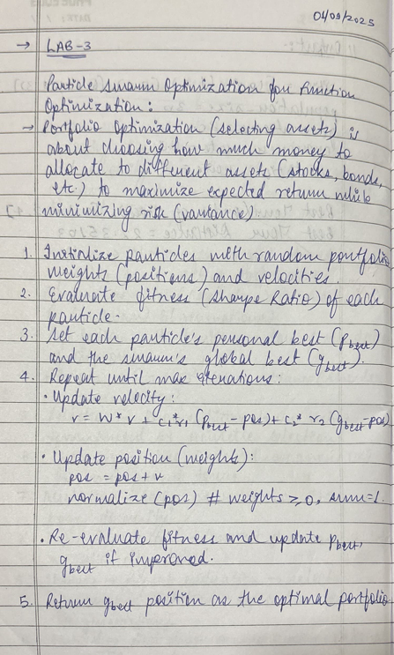

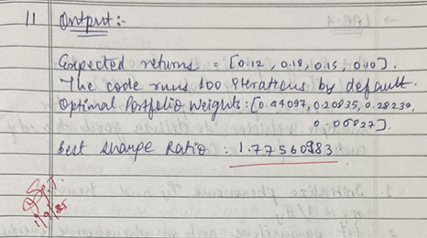

Code:

import numpy as np

# ---------- Step 1: Define Problem (Portfolio Optimization) ----------

# Expected returns for 4 assets (example data)

returns = np.array([0.12, 0.18, 0.15, 0.10])

# Covariance matrix of returns (risk measure)

cov_matrix = np.array([

[0.010, 0.002, 0.001, 0.003],

[0.002, 0.030, 0.002, 0.004],

[0.001, 0.002, 0.020, 0.002],

[0.003, 0.004, 0.002, 0.025]

])

# Fitness function: Sharpe ratio (maximize return / risk)

def fitness(weights):

weights = np.array(weights)

portfolio_return = np.dot(weights, returns)

portfolio_risk = np.sqrt(np.dot(weights.T, np.dot(cov_matrix, weights)))

if portfolio_risk == 0: # avoid division by zero

return -999

return portfolio_return / portfolio_risk

# ---------- Step 2: Initialize PSO Parameters ----------

num_particles = 30

num_assets = len(returns)

iterations = 100

w = 0.7 # inertia weight

c1 = 1.5 # cognitive coefficient

c2 = 1.5 # social coefficient

# ---------- Step 3: Initialize Particles ----------

positions = np.random.dirichlet(np.ones(num_assets), size=num_particles) # weights sum=1

velocities = np.random.rand(num_particles, num_assets) * 0.1

personal_best_positions = positions.copy()

personal_best_scores = np.array([fitness(p) for p in positions])

global_best_position = personal_best_positions[np.argmax(personal_best_scores)]

global_best_score = np.max(personal_best_scores)

# ---------- Step 4: Main Loop ----------

for _ in range(iterations):

for i in range(num_particles):

# Update velocity

r1, r2 = np.random.rand(num_assets), np.random.rand(num_assets)

velocities[i] = (w * velocities[i]

+ c1 * r1 * (personal_best_positions[i] - positions[i])

+ c2 * r2 * (global_best_position - positions[i]))

# Update position (weights must be valid portfolio)

positions[i] += velocities[i]

positions[i] = np.maximum(positions[i], 0) # no negative weights

positions[i] /= np.sum(positions[i]) # normalize to sum=1

# Evaluate fitness

score = fitness(positions[i])

# Update personal best

if score > personal_best_scores[i]:

personal_best_scores[i] = score

personal_best_positions[i] = positions[i].copy()

# Update global best

if score > global_best_score:

global_best_score = score

global_best_position = positions[i].copy()

# ---------- Step 5: Output Result ----------

print("Optimal Portfolio Weights:", global_best_position)

print("Best Sharpe Ratio:", global_best_score)

Output:



**Program 4**

Ant Colony Optimization (ACO) for the Vehicle Routing Problem (VRP): It involves finding optimal routes for multiple vehicles to deliver goods to a set of customers from a central depot.

Algorithm:

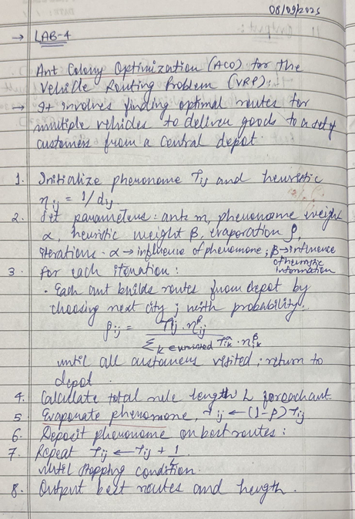

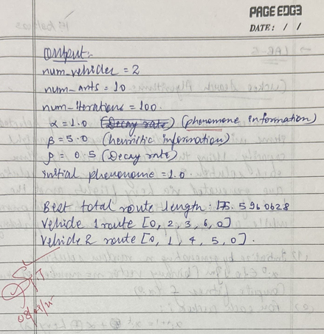

Code:

import numpy as np

import random

# Coordinates of depot + customers (0 is depot)

coords = np.array([

[40, 50], # depot

[45, 68], [50, 30], [55, 20], [60, 80], [65, 60], [70, 40]

])

num_vehicles = 2

num_ants = 10

num_iterations = 100

alpha = 1.0 # pheromone importance

beta = 5.0 # heuristic importance (inverse distance)

rho = 0.5 # pheromone evaporation rate

initial_pheromone = 1.0

num_cities = len(coords)

# Distance matrix

dist_matrix = np.sqrt(((coords[:, None] - coords[None, :])**2).sum(axis=2))

# Heuristic matrix (inverse distance), avoid division by zero

heuristic = 1 / (dist_matrix + np.diag([np.inf]*num_cities))

# Initialize pheromone trails

pheromone = np.ones((num_cities, num_cities)) * initial_pheromone

def choose_next_city(current_city, unvisited, pheromone, heuristic):

pheromone_vals = pheromone[current_city][unvisited] ** alpha

heuristic_vals = heuristic[current_city][unvisited] ** beta

probs = pheromone_vals * heuristic_vals

probs /= probs.sum()

return np.random.choice(unvisited, p=probs)

def construct_solution():

routes = [[] for _ in range(num_vehicles)]

unvisited = set(range(1, num_cities)) # customers only

for v in range(num_vehicles):

routes[v].append(0) # start from depot

while unvisited:

for v in range(num_vehicles):

current_city = routes[v][-1]

candidates = list(unvisited)

if not candidates:

break

next_city = choose_next_city(current_city, candidates, pheromone, heuristic)

routes[v].append(next_city)

unvisited.remove(next_city)

if not unvisited:

break

# Return to depot

for v in range(num_vehicles):

routes[v].append(0)

return routes

def route_length(route):

length = 0

for i in range(len(route)-1):

length += dist_matrix[route[i], route[i+1]]

return length

best_routes = None

best_length = float('inf')

for iteration in range(num_iterations):

all_routes = []

all_lengths = []

for _ in range(num_ants):

routes = construct_solution()

total_length = sum(route_length(r) for r in routes)

all_routes.append(routes)

all_lengths.append(total_length)

if total_length < best_length:

best_length = total_length

best_routes = routes

# Pheromone evaporation

pheromone *= (1 - rho)

# Pheromone update (only best ant deposits pheromone)

for route in best_routes:

for i in range(len(route)-1):

from_city = route[i]

to_city = route[i+1]

pheromone[from_city][to_city] += 1 / best_length

pheromone[to_city][from_city] += 1 / best_length

print("Best total route length:", best_length)

for v, route in enumerate(best_routes):

print(f"Vehicle {v+1} route: {route}")

Output:

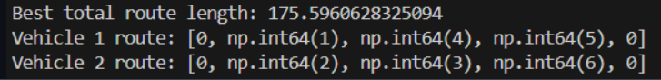

**Program 5**

Cuckoo Search Algorithms: We need to maximize the total value of selected items without exceeding the knapsack's weight capacity. Using the Cuckoo Search Algorithm, each solution is a binary vector, new solutions are generated via Lévy flights, and the best feasible solution is iteratively improved while abandoning poor solutions with a probability.

Algorithm:

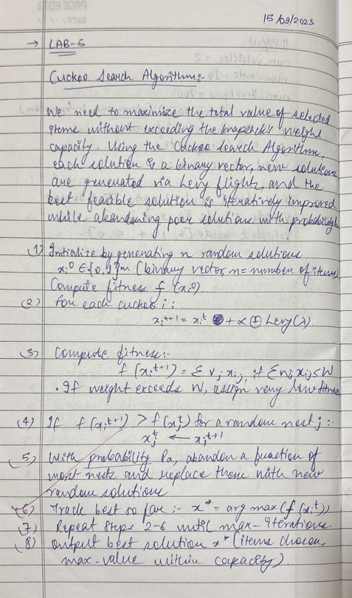

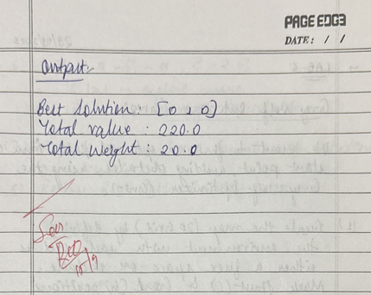

Code:

import numpy as np

import random

# ---------------- Knapsack Problem Setup ----------------

# Example items: (value, weight)

items = [(60, 10), (100, 20), (120, 30)]

capacity = 50

n = len(items)

def fitness(solution):

total_value = total_weight = 0

for i in range(n):

if solution[i] == 1:

total_value += items[i][0]

total_weight += items[i][1]

if total_weight > capacity:

return 0 # invalid solution

return total_value

# ---------------- Cuckoo Search Algorithm ----------------

def levy_flight(Lambda):

u = np.random.normal(0, 1) * np.power(abs(np.random.normal(0, 1)), -1.0 / Lambda)

v = np.random.normal(0, 1)

step = u / abs(v) ** (1 / Lambda)

return step

def get_random_solution():

return [random.randint(0, 1) for _ in range(n)]

def cuckoo_search(num_nests=10, pa=0.25, max_iter=100):

nests = [get_random_solution() for _ in range(num_nests)]

best = max(nests, key=fitness)

for _ in range(max_iter):

# Generate new solution via Levy flight

cuckoo = best[:]

step = int(abs(round(levy_flight(1.5)))) % n

pos = random.randint(0, n-1)

cuckoo[pos] = 1 - cuckoo[pos] # flip bit

# Replace a random nest if better

j = random.randint(0, num_nests-1)

if fitness(cuckoo) > fitness(nests[j]):

nests[j] = cuckoo

# Abandon some nests with probability pa

for i in range(num_nests):

if random.random() < pa:

nests[i] = get_random_solution()

# Update best

best = max(nests, key=fitness)

return best, fitness(best)

# ---------------- Run the algorithm ----------------

solution, value = cuckoo_search()

print("Best solution:", solution)

print("Total value:", value)

Output:

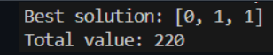

**Program 6**

Using the Grey Wolf Optimizer (GWO), we aim to find the shortest, obstacle-free path by modeling the search agents (wolves) to iteratively converge toward the best position (path node) in the environment. The algorithm simulates the grey wolves' hunting hierarchy and encircling behavior to efficiently navigate the space from the start point.

Algorithm:

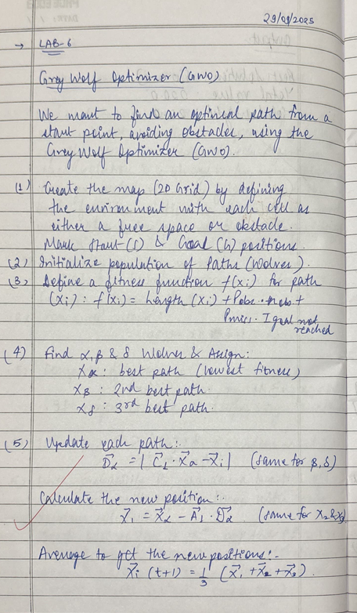

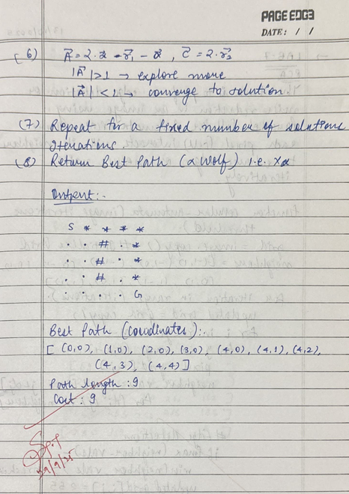

Code:

import numpy as np

import random

# === Grid setup ===

GRID_SIZE = 5

START = (0, 0)

GOAL = (4, 4)

OBSTACLES = [(2, i) for i in range(1, 4)] # Vertical wall in column 2, rows 1 to 3

# === Parameters ===

POP_SIZE = 10

MAX_ITER = 50

PATH_LENGTH = 20 # fewer steps needed for small grid

# === Helper Functions ===

def is_valid(pos):

x, y = pos

return 0 <= x < GRID_SIZE and 0 <= y < GRID_SIZE and pos not in OBSTACLES

def move_toward_goal(current):

moves = [(0,1), (1,0), (0,-1), (-1,0)]

random.shuffle(moves)

cx, cy = current

gx, gy = GOAL

moves.sort(key=lambda m: abs((cx + m[0]) - gx) + abs((cy + m[1]) - gy))

for dx, dy in moves:

new_pos = (cx + dx, cy + dy)

if is_valid(new_pos):

return new_pos

return current

def generate_random_path():

path = [START]

visited = set(path)

current = START

for _ in range(PATH_LENGTH):

current = move_toward_goal(current)

if current in visited:

continue

path.append(current)

visited.add(current)

if current == GOAL:

break

return path

def path_cost(path):

cost = len(path)

if path[-1] != GOAL:

dist = abs(path[-1][0] - GOAL[0]) + abs(path[-1][1] - GOAL[1])

cost += 100 + dist

for pos in path:

if pos in OBSTACLES:

cost += 50

return cost

# === GWO Optimization ===

def gwo_optimize():

wolves = [generate_random_path() for _ in range(POP_SIZE)]

for iteration in range(MAX_ITER):

wolves.sort(key=path_cost)

alpha, beta, delta = wolves[0], wolves[1], wolves[2]

a = 2 - iteration * (2 / MAX_ITER)

for i in range(3, POP_SIZE):

new_path = []

for j in range(min(len(alpha), len(wolves[i]), PATH_LENGTH)):

A = 2 * a * random.random() - a

C = 2 * random.random()

x_alpha = np.array(alpha[j])

x_wolf = np.array(wolves[i][j])

D_alpha = abs(C * x_alpha - x_wolf)

X1 = x_alpha - A * D_alpha

A = 2 * a * random.random() - a

C = 2 * random.random()

x_beta = np.array(beta[j])

D_beta = abs(C * x_beta - x_wolf)

X2 = x_beta - A * D_beta

A = 2 * a * random.random() - a

C = 2 * random.random()

x_delta = np.array(delta[j])

D_delta = abs(C * x_delta - x_wolf)

X3 = x_delta - A * D_delta

X_new = (X1 + X2 + X3) / 3

X_new = tuple(map(int, np.clip(np.round(X_new), 0, GRID_SIZE - 1)))

if is_valid(X_new):

new_path.append(X_new)

else:

if new_path:

new_path.append(move_toward_goal(new_path[-1]))

else:

new_path.append(move_toward_goal(START))

wolves[i] = new_path

best_path = sorted(wolves, key=path_cost)[0]

return best_path

# === Textual Output ===

def print_grid(path):

grid = [["." for _ in range(GRID_SIZE)] for _ in range(GRID_SIZE)]

for x, y in OBSTACLES:

grid[y][x] = "#" # Obstacle

for x, y in path:

if (x, y) != START and (x, y) != GOAL and grid[y][x] != "#":

grid[y][x] = "*"

sx, sy = START

gx, gy = GOAL

grid[sy][sx] = "S"

grid[gy][gx] = "G"

print("\n=== GWO Path Grid ===")

for row in grid:

print(" ".join(row))

print("\nBest Path (coordinates):")

print(path)

print(f"\nPath Length: {len(path)}")

print(f"Cost: {path_cost(path)}")

# === Run ===

best = gwo_optimize()

print_grid(best)

Output:

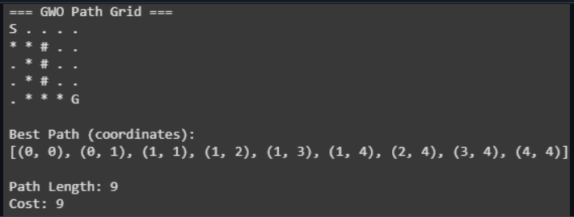

**Program 7**

The task is to perform edge detection or noise reduction in an image using Parallel Cellular Automata (PCA), where each pixel (cell) interacts with its neighbors to enhance edges or reduce noise iteratively.

Algorithm:

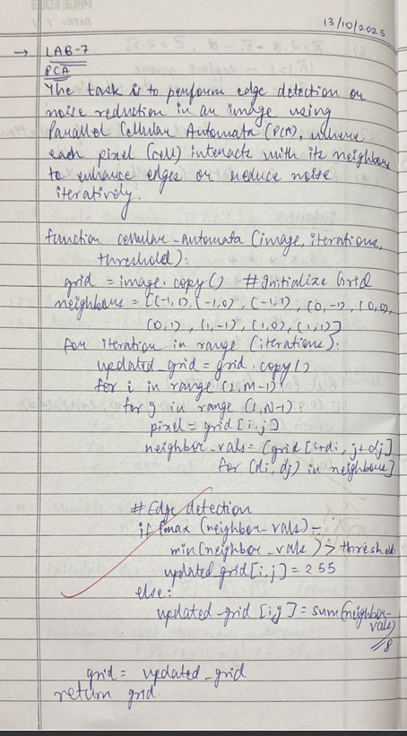

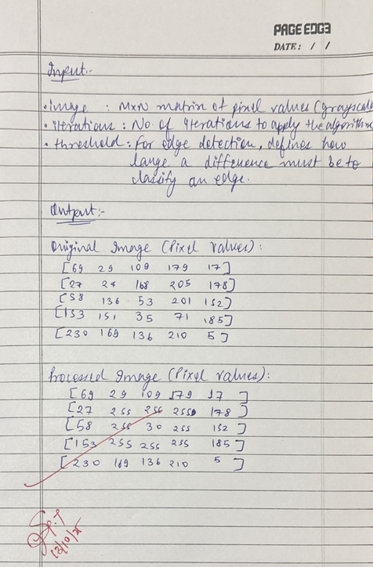

Code:

import numpy as np

import cv2

import matplotlib.pyplot as plt

# Function for Cellular Automata (Edge Detection or Noise Reduction)

def cellular_automata(image, iterations=10, threshold=30):

grid = image.copy() # Initialize grid (image as 2D array)

neighbors = [(-1, -1), (-1, 0), (-1, 1), (0, -1), (0, 0), (0, 1), (1, -1), (1, 0), (1, 1)]

for iteration in range(iterations):

updated_grid = grid.copy()

for i in range(1, len(grid) - 1): # Loop through pixels (excluding borders)

for j in range(1, len(grid[0]) - 1):

pixel = grid[i, j]

neighbor_vals = [grid[i+di, j+dj] for (di, dj) in neighbors]

# Edge detection: large difference with neighbors indicates edge

if max(neighbor_vals) - min(neighbor_vals) > threshold:

updated_grid[i, j] = 255 # Edge pixel

else:

# Noise reduction: average with neighbors for smoothing

new_pixel_value = sum(np.clip(neighbor_vals, 0, 255)) // 8 # Clipping before averaging

# Clip the new pixel value to the range 0-255

updated_grid[i, j] = np.clip(new_pixel_value, 0, 255)

grid = updated_grid # Update the grid with new values

return grid # Output updated image

# Set numpy to ignore overflow warnings

np.seterr(over='ignore')

# Generate a smaller dummy grayscale image (random noise)

# Create a 5x5 pixel image with random values between 0 and 255

image = np.random.randint(0, 256, (5, 5), dtype=np.uint8)

# Print the original image

print("Original Image (Pixel Values):")

for row in image:

print(row)

# Apply the cellular automata algorithm

iterations = 10

threshold = 30

processed_image = cellular_automata(image, iterations, threshold)

# Print the processed image

print("\nProcessed Image (Pixel Values):")

for row in processed_image:

print(row)

# Visualize the images using matplotlib

plt.figure(figsize=(8,4))

plt.subplot(1,2,1)

plt.title('Original Image')

plt.imshow(image, cmap='gray', vmin=0, vmax=255)

plt.axis('off')

plt.subplot(1,2,2)

plt.title('Processed Image')

plt.imshow(processed_image, cmap='gray', vmin=0, vmax=255)

plt.axis('off')

plt.tight_layout()

plt.show()

Output:

